- Dataset provenance and description
The dataset source used for the project is the National Institute of Health (NIH) Clinical Center, and the dataset name is NIH ChestX-ray14, it can be obtained from: https://nihcc.app.box.com/v/ChestXray-NIHCC
According to the FAQ on the website listed above, usage of the dataset is unrestricted. The authors, Wang et al. (2017), requested a link to the download site (as above), as well as acknowledgement through citation of their paper. No specific license is listed.

- Dataset size and characteristics
The dataset contains 112120 frontal chest X-ray images of 30805 unique patients stored across 12 compressed folders with a total size of 42 GB. For this project, the first four compressed folders were downloaded, containing 34999 images with total size of 12.7 GB, and 4 GB of processing data was selected, which will be used for the MapReduce task. The data is in the .png and .csv file formats. The image dataset was first published in September 2017, and the metadata was first published in November 2017 and was last updated in April 2020.

- Data preparation and quality
The metadata file was imported containing image index, finding labels, follow-up, patient ID, patient sex, view position, original image [width & height] and original image pixel spacing [ x & y]. The subset of the data corresponding to the selected working dataset was extracted, which contained 34999 images for 9232 unique patients. The data was checked for missing values, class imbalance and duplicates. We found that there were missing values nor duplicates, however there is a significant class imbalance in the data. This may influence analysis outcomes therefore class imbalance needs to be considered when working with this data. Transformation of multi-label disease annotation was performed, and individual binary indicator columns were created for each disease category. A column for the number of diseases per image was generated.

- Exploratory Data Analysis
Exploratory data analysis was performed to understand the patterns within the dataset.
Patient age distribution: from Figure 1 it is clear that the working dataset contains a wide age range with most patients falling between the range of 40-60 years.
Disease Frequency: Figure 2 shows a subsequent variation among the diseases. Most of the images present No Findings disease label, followed by Infiltration, effusion and atelectasis which are common diseases represented in the images. Edema, pneumonia and Hernia are the least common diseases represented in the images. It is evident that there is a class imbalance in the dataset as discussed in the data preparation and quality section.
Disease Occurrence by Gender: As shown in Figure 3 disease frequencies were compared across male and female patients. The results showed a slight difference for disease occurrence between males and females with males having high numbers for Atelectasis and Infiltration. While the dataset alone cannot provide potential meaningful patterns, further investigation can reveal meaningful demographic patterns.

- Discussion of 7 Vs
Volume: The total dataset consists of 112120 images at 1024 * 1024 resolution. This could arguably be classified as a voluminous big data dataset. The metadata is only a total of 8.6MB, which marks a stark contrast with the size of data it represents.
Velocity: Since the dataset is no longer expected to grow, it can be assumed to be static and will be processed in batch fashion, so for our activities we do not need to make considerations for incoming streaming data - this makes Velocity one of the weakest Vs.
Variety: In terms of Variety, we have a mixture of unstructured image files, with structured metadata containing categorical and numerical data.
Value: This specific dataset has been used in numerous papers, underpinning their findings. It could therefore be considered a benchmark in model training for Chest X-Rays. The authors of the paper remarked that there was a severe limitation of only 4143 frontal images available to a prior paper. The more data that is collected and made publicly available strengthens the data science community in being able to build deep learning models with the proliferation of these types of datasets.
Veracity: The authors of the paper argue that the accuracy of the labels is above 90%. As previously mentioned, the dataset is a benchmark that has been widely used in other studies. This leads to it being a very relevant and trustworthy source of data.
Variability: For our dataset, variability is not a factor. This is especially true since the data is not streamed but could be considered as batched data. The image data is currently not being updated, so we could conclude that this dataset has low variability.
Visualisation: Image data is high dimensional data and the benefit of using visualisation tools is that it helps communicate information that’s difficult to grasp at such large scales of data, as we can see demonstrated by the plots from our EDA. A quick glance is able to relay information that would otherwise be difficult to infer from the data. For a sample of images with diagnosis refer to Figure 4 and for comparison between healthy and diseased images refer to Figure 5

- Potential societal/business value and insights
The societal value that would come from models trained on datasets is that it would improve patient access to radiological services. In some places, such as in rural areas, radiologists are not readily available. This would help to bridge that gap, but should ultimately not be treated as medical advice, lest finding corroborated by a specialist.
Limitations for this dataset doesn’t include many demographic fields, including race, which could be used to see which diseases are more prevalent for whom. The second is that this dataset is from a single institution, so the dataset would not do well with generalizability.

References
Wang, X., Peng, Y., Lu, L., Lu, Z., Bagheri, M., & Summers, R. M. (2017). ChestX-Ray8: Hospital-Scale Chest X-Ray Database and Benchmarks on Weakly-Supervised Classification and Localization of Common Thorax Diseases. 2017 IEEE Conference on Computer Vision and Pattern Recognition (CVPR), 3462–3471. https://doi.org/10.1109/CVPR.2017.369

Appendix
GitHub Repo Link: https://github.com/Nokubongwa/MIT-805-Big-Data-Project
Figure 1: Age Distribution of Patients
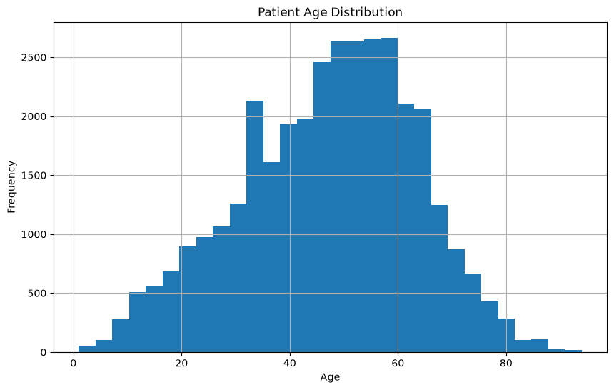
Figure 2: Disease Frequency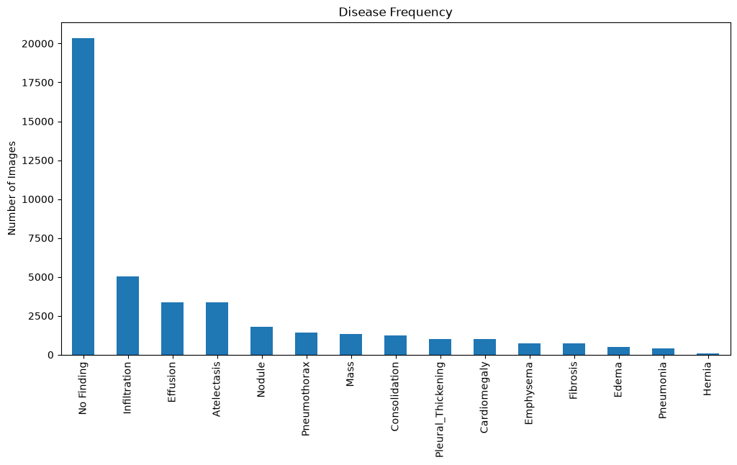
Figure 3: Disease Occurrence by Gender
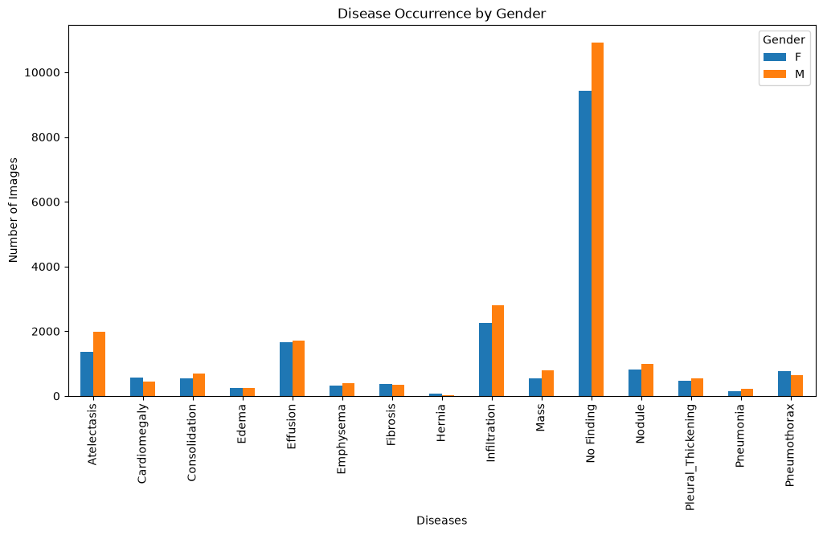
Figure 4: Sample of images with diagnosis
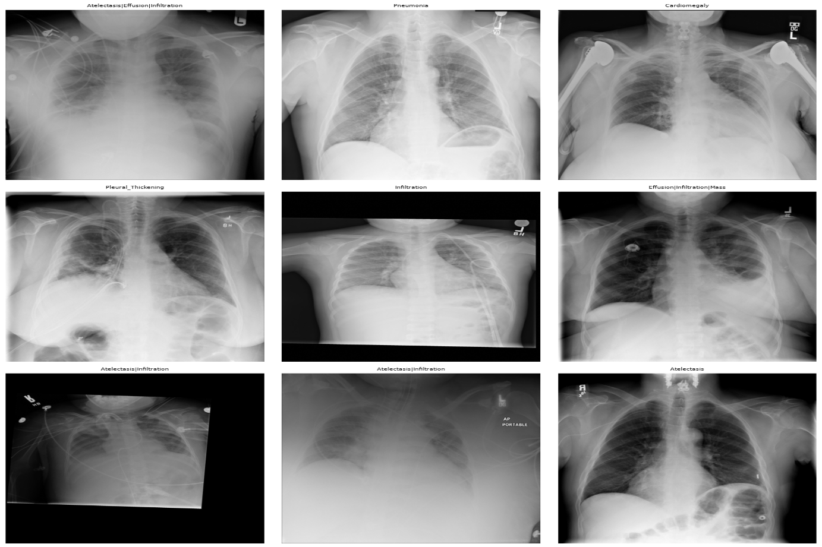

Figure 5: Healthy vs Diseased Images
